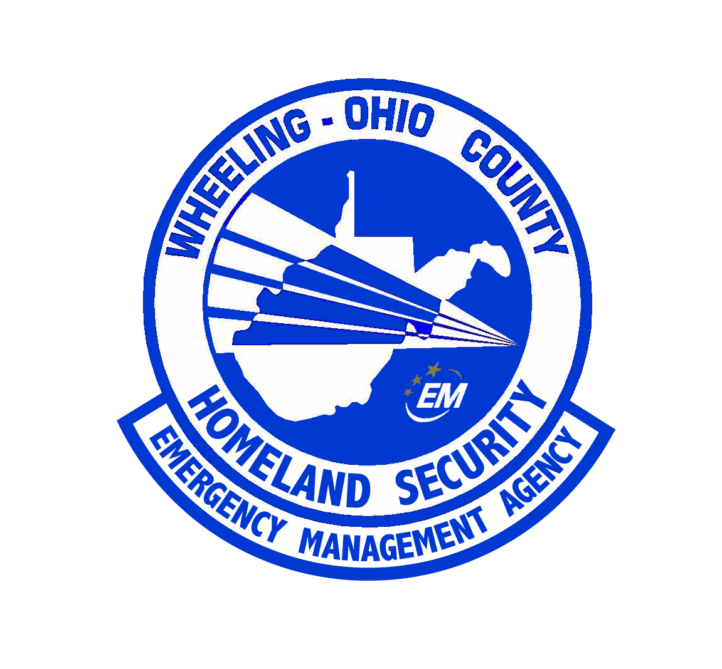 | WHEELING – OHIO COUNTY  HOMELAND SECURITY AND  EMERGENCY MANAGEMENT AGENCY  1500 CHAPLINE ST.  WHEELING, W.V. 26003
JOB DESCRIPTION
DEPUTY DIRECTOR

Job Title: Wheeling – Ohio Co. Homeland Security and Emergency Management Agency (WOCHSEMA) Deputy Director.
Shift: Primarily dayshift, may require altered schedule for special assignments and training; available for “on-call” and callouts for EOC activations.
Hours: 40 hours week, salary position.
Supervisor: Director

General position description:
The Deputy Director of WOCHSEMA will serve as the second person in command within the WOCHSEMA. Under limited supervision by the Director, performs full performance level work and supervisory tasks calling for interpretation and application of agency policies, procedures, laws, rules, regulations, etc.
At this level, the predominate tasks require the understanding of the broader scope of the work functions and requires an ability or a specific skill to a variety of related tasks requiring multiple steps or decisions. The steps of each task allow the employee to operate with latitude of independence. Contacts are usually informational and intergovernmental.
Work schedule may consist of irregular hours and may require more than a 40-hour week in times of an emergency and a disaster. The Deputy Director must be willing to be “on call” and available when needed.

Example of duties:
NOTE: The following are intended to illustrate typical duties; they are not meant to be all-inclusive or restrictive.
- Respond to the EOC during times of either partial or full-scale activation of the EOC.
- Responds to emergency incidents throughout the county at the request of the Director or on-call procedure.
- Acts as Public Information Officer for the agency in the absence of the Director.
- Develops plans and procedures for review by the Director and Ohio County Commission for all forms of disaster response and recovery assistance with Ohio County.
- Coordinates the annual review and update of Emergency Operations Plan, Evacuation Plan, Severe Weather Plan, and other essential emergency plans with the HSEMA team.
- Assists the Director with planning initiatives with those at the state level and those of the neighboring jurisdictions.
- Assists with coordinating aspects of the Emergency Operations Center, which could include activating the EOC, preparation of reports, ensuring smooth operations and assisting individuals who may require EOC services.
- Assists in the development of plans to protect critical infrastructure and plans to address continuity of Ohio County government and continuity of operations.
- Assists in performing local risks assessments to develop planning priorities within Ohio County.
- Assists in the research, writing and administer grant applications for WOCHSEMA, LEPC, and HIRT.
- Assists in preparing EMPG (Emergency Management Performance Grant) quarterly reports and other financial reimbursement reports to the West Virginia Division of Homeland Security and Emergency Management.
- Assists Administrative team in the development of annual budget request.
- Attends day and/or evening meetings as required or requested by the Director.
- Assists in conducting continuing public awareness and educations campaigns about emergency preparedness, 9-1-1 and emergency response organizations.
- Assist local response organizations in public education efforts.
- Assists in training personnel who will carry out response and recovery functions related to response and recovery programs.
- Attend training sessions, both local and out of town as required.
- Develops and maintains operation plans and procedures for use during EOC activation.
- Acts as the Deputy Chairperson of the Ohio County Local Emergency Planning Committee. Also serves on the Courthouse Security committee.
- Assists with local addressing efforts for Ohio County, along with the Planning Officer and 911 Director to include updating the Ohio County MSAG, addressing for new structures and subdivisions (outside of the City of Wheeling), street signage requests to WV DOH and Ohio County Development Authority.
- The Deputy Director is responsible for maintaining the Emergency Operations Center, the Mobile Command Truck, and all trailered equipment of the Agency.
- The Deputy Director shall serve as EMS Supervisor for the Ohio County Emergency Medical Service.
- The EMS Supervisor shall be certified as a Paramedic and must have five (5) years of experience as a Paramedic.
- The EMS Supervisor reports to the EMS Director.
- The EMS Supervisor provides high level of care, capable of administering powerful drugs and techniques, and can administer Basic Life Support and Advanced Life Support techniques and protocols. Paramedics can serve as attendant-in-charge on class A, B, and C (advanced life support transport) vehicles.
- The EMS Supervisor may render rescue, basic first aid, and cardiopulmonary resuscitation services, and all procedures as listed in the Paramedic Job Description.
- In addition, the Supervisor shall:
  - Oversee the daily operation and staffing of the Ohio County E.M.S.
  - Maintains EMS staff employee records and assures current certification and Continuing Education.
  - Responsible for all EMS Equipment Maintenance.
  - Supervise all EMS Staff.
  - Serve as the Squad Training Officer.
  - Responds to all EMS calls as required and serves as an additional Paramedic as needed.
  - Prepares requests for the Director for supplies, equipment, and other budgetary needs.

Supervision Received
- Work under the general supervision of the Director.

Supervision Exercised
- Manage all HSEMA employees.

Knowledge
- Knowledge of emergency management phases and methodology
- Basic knowledge of the E911 system
- Knowledge of basic office equipment and process
- Knowledge of computer operations (Word, Excel, Power Point. And Outlook)
- Knowledge of the community, including major facilities, highways, streets, landmarks, waterways, etc.

Skills
- Skills in basic map reading.
- Skilled in reading and understanding complex technical documents such as laws, ordinances, procedures and technical manuals.
- Skilled in organizing and analyzing a variety of information and applying selected knowledge.
- Skilled in management of employees and employee relations

Abilities
- Ability to communicate effectively before groups of employees.
- Ability to communicate both orally and in writing.
- Ability to read and interpret documents such as operating and maintenance instructions, and procedure manuals.
- Ability to perform duties under stress with speed and accuracy.
- Ability to sit continuously for long periods in a tobacco free environment with minimal breaks.

