WHEELING-OHIO COUNTY
EMERGENCY MANAGEMENT AGENCY
EMERGENCY OPERATIONS PLAN

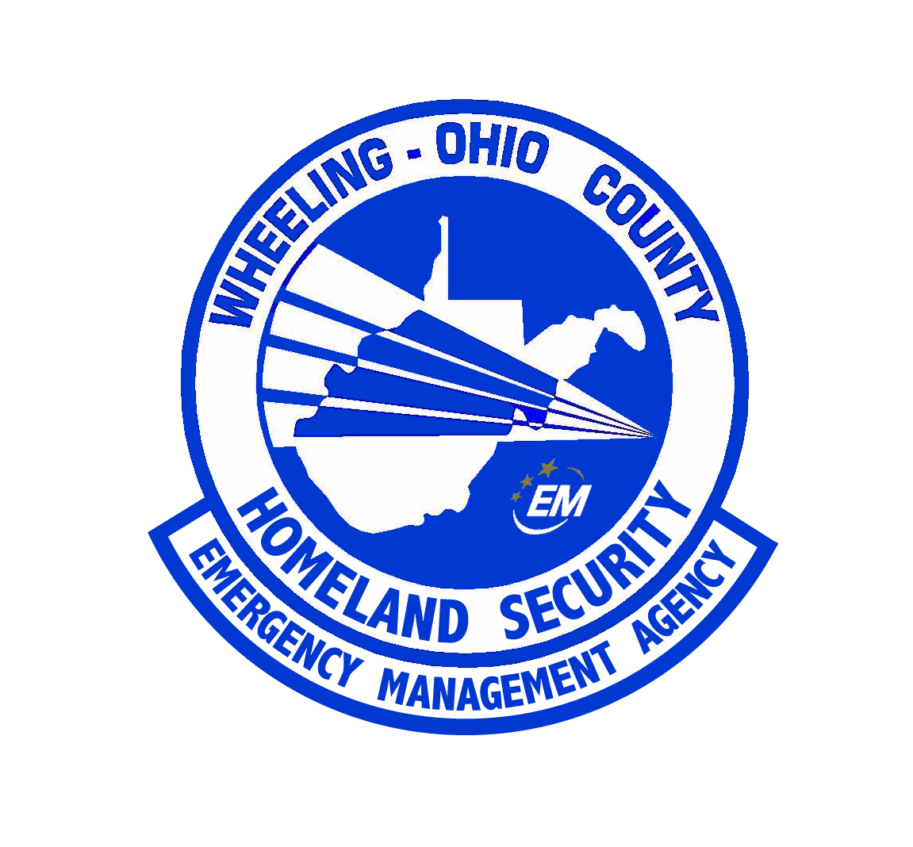

ANNEX SUMMARY INFORMATION PAGE

ANNEX DESIGNATION: | Public Health and EMS
RELATED FEDERAL ESF: | 8
PURPOSE OF ANNEX: | To provide guidance and administration of the county's resources during periods of emergency in order to provide for the health and medical welfare of the public.  The mission of this plan is to ensure mobilization, management, and delivery of public health services under disaster or emergency conditions. Response to such emergencies may require the coordinated efforts of multiple states and counties.
WEST VIRGINIA STATUTORY AUTHORITY: | WV §15-5; WV §16-4C-18, Title 44 §205-740; PL 288 §415
PRIMARY AGENCY: | Wheeling – Ohio County Health Department
SUPPORT AGENCIES: | Wheeling – Ohio County Emergency Management Agency, Ohio County Commission,  City of Wheeling, Village of Bethlehem, Town of Triadelphia, Village of Clearview, Village of Valley Grove, and Village of West Liberty.
REFERENCES: | “Guide for All Hazards Emergency Operations Planning”, SLG 101, FEMA, 1996  “Wheeling - Ohio County Emergency Operations Plan”, 2004  “West Virginia Emergency Operations Plan”, Office of Emergency Services, 2002

ANNEX ESF 8
PUBLIC HEALTH and MEDICAL SERVICES

I. PURPOSE

To provide guidance and administration of the county's resources during periods of emergency in order to provide for the health and medical welfare of the public.

The mission of this plan is to ensure mobilization, management, and delivery of public health services under disaster or emergency conditions. Response to such emergencies may require the coordinated efforts of multiple states and counties.

II. SITUATIONS AND ASSUMPTIONS

A. The Ohio County Commission has the overall responsibility for the protection of lives, property, and the health and well-being of all the citizens of the county.

B. During most public health emergencies, the Ohio County Emergency Operations Center shall be activated, in cooperation with the Wheeling – Ohio County Health Department which will serve as lead agency. For epidemiologically identified “hot spots” in an area of the county or in a community, an on-site command post, Mobile Emergency Operations Center, or triage center may be set up by the on-scene incident commander.

- EMS is most critical within the first 15 to 30 minutes of the disaster.

D. Mutual aid assistance usually arrives after the first critical 15 to 30 minutes. Mutual aid is addressed in the Northern West Virginia Regional Mass Casualty Plan (see Appendix #1). Mutual aid agreements have been established with other local health departments in the region. Ohio County has established mutual aid agreements with neighboring counties in West Virginia, Ohio, and Pennsylvania. Also, all states of the union participate in the Federal Emergency Mutual Aid Consortium (EMAC).

E. The initial medical care during an emergency situation (other than first aid rendered by fireman and/or civilians) will be rendered by EMS personnel.

- Triage teams, made up of doctors and nurses from local hospitals, can be an important addition to the initial on-scene medical care. Personnel from the West Virginia Regional Response Teams will also support local efforts.

- All public health and private medical/health, mortuary, and human resources will become available during a state or federally declared public health emergency or disaster; however, many of these resources may be directly affected by the disaster and as a result, unable to respond or only able to respond in a limited fashion.

- During a public health emergency, the number of patients/victims may overwhelm the capability of the local hospitals. Plans for surge capacity have been made and are part of the Region X-XI Bio-Terrorism Response plan (see Appendix #2).

- Providing for the relocation and care of special populations such as nursing homes, elderly group home residents, handicapped and invalids in private homes, and others requiring special care will be addressed and completed.

III. CONCEPT OF OPERATIONS

A. GENERAL

Medical care is a primary concern during all phases of Emergency Management. Particularly during the response phase, the initial care administered by EMS and triage teams can have a serious effect on the survivability of disaster victims.

The importance of the hospitals, with their ability to provide major care for life threatening injuries, is obvious. The local emergency management organizations, in conjunction with local hospitals, should take all actions necessary to insure the continued functions of the hospitals in an emergency situation. Emergency operations for public health services will be an extension of normal duties, as defined by Chapter 16, Article 2 of the WV Code. One of the primary concerns of public health personnel is disease control which involves the detection and control of disease-causing agents, as well as purification of water.

Sanitation is a very significant aspect of public health. One of the primary considerations is the continuation of waste disposal under disaster conditions. Medical facilities and food establishments require sanitation inspections.

B. PHASES OF MANAGEMENT

1. Mitigation

Mitigation shall be the prime concern of the Wheeling - Ohio County Health Department. Mitigation will be best carried out through the day-to-day function of the Immunization and Health Inspection Program. In the event of a nuclear situation, the Wheeling - Ohio County Health Department, in conjunction with the State Department of Health, the Nuclear Regulatory Agency, and the Surgeon General would distribute thyroid blocking potassium iodine as outlined in the Federal Response Plan.

2. Preparedness

Emergency organizations shall develop the appropriate plans, Standard Operating Procedures (SOP's), training, current internal notification/recall rosters, and communications to meet the potential emergency situations probable in the county. This would include EMS, local hospitals, and the Wheeling - Ohio County Health Department. These agencies, in cooperation with other emergency agencies, should exercise their capabilities regularly.

3. Response

The response phase will include triage, stabilization, and transportation of casualties from the triage area to a fixed medical facility. The response phase will also include disease control and efforts to include sanitation activities. Implementation of the mental health response shall be completed to care for those affected by the incident.

In response to acts of terrorism, especially bioterrorism, specific response procedures for EMS and the Wheeling – Ohio County Health Department will be needed. These procedures are found in Annex T of the Wheeling – Ohio County Emergency Operations Plan.

4. Recovery

The recovery phase will be a continuation of the response phase for as long as it is deemed necessary by the Director of the Wheeling - Ohio County EMA to adequately handle the needs of the people. Critical Incident Stress Debriefing shall be offered as part of the Recovery Phase to all members of the local health department as part of the over-all recovery effort.

C. SPECIAL SITUATIONS

- In the event of a radiation accident, the Ohio County Radiological Officer, with the assistance of State Radiological personnel, will establish appropriate contamination controls in response to actual conditions. Where possible, individuals will be decontaminated prior to being removed from the affected area. However, necessary prompt medical treatment takes precedence over decontamination. EMS vehicles contaminated during emergency operations will be removed from service after the completion of emergency operations and until such time as they can be decontaminated.

All public health personnel will be trained in radiological monitoring to be used in their response to radiological incidents. Each staff member will be assigned a personal dosimeter.

2. Medical advice on the treatment of radiologically contaminated persons, or significantly overexposed persons is available through the State Department of Health.

3. The Ohio County Radiological staff will determine and record the radiation levels of contaminated and exposed personnel.

IV. ORGANIZATION

A. ORGANIZATION

1. The Wheeling - Ohio County Health Department is responsible for developing health and medical services plans within the framework of the state health and medical services plan and operating within the legal authority delegated to the county, including its municipalities. Responding agencies are responsible for developing SOP's that coordinate with the county and provide an adequate response.

2. Within the framework of "government in emergency", the Office of Emergency Services will include all government services. The Health Department will be known as Health and Medical Services.

3. County agencies normally responsible for public health and welfare will provide these services during an emergency to the extent of their capability. State and private agencies (such as the Red Cross and Salvation Army) will be called upon for assistance as necessary.

B. TASK ASSIGNMENTS

1. Emergency Medical Services

a. Prepare triage area.

b. Perform triage on casualties.

- Provide transportation from triage area to fixed medical facility.

d. Provide medical support and radiological decontamination to response personnel.

e. Assist in evacuation.

f. Assist in warning activities.

- Provide transportation care of elderly and handicapped.

- Provide medical care in shelter/congregate care facilities.

- Provide a mutual aid agreement with surrounding jurisdictions.

2. Hospitals

- Provide intensive and long-term medical care.

- Stabilize casualties before transportation to specialist facilities.

c. Provide doctors and nurses for triage teams.

- Provide shelter for evacuees from other hospitals or nursing homes impacted by the disaster.

3. Wheeling - Ohio County Health Department

- Re-establishes health and sanitary services in affected areas.

b. Establishes health and sanitary services in reception and mass care centers in the event of an evacuation.

c. Supervises food and drug supplies including monitoring potentially contaminated supplies, and providing alternate uncontaminated supplies. The State Department of Agriculture will assist in locating alternate supplies of food when radiation is present.

- Supervises potable water supplies. The State Department of Health will assist in monitoring and sampling water supplies. The State Department of Environmental Protection will identify unaffected sources of water, and the State Department of Highways will provide appropriate tank trucks to transport these supplies, if necessary.

- Supervises food preparation facilities for mass care centers.

f. Assists the Wheeling – Ohio County Emergency Management Agency in the relocation and care of special populations, such as nursing homes, group home residents, invalids in private homes, and others requiring special care (as well as insuring that patients who cannot be moved are cared for by medical staff.)

g. Provides detailed instructions for handling the deceased (included under Appendix #3).

- Continues normal administrative and control procedures if the disaster that occurs can be handled without calling into operations other governmental or non-governmental health forces. If the disaster that occurs is of a magnitude that indicates that resources of the local department will be overtaxed, the West Virginia Bureau of Public Health will respond in accordance to the prescribed doctrines.

- Requests personnel from adjoining county health departments if additional resources are necessary to cope with the emergency.

- Assists in establishing emergency medical care shelters in suitable buildings close to the point of the disaster as required and requested by the Incident Commander. Requests Strategic National Stockpile assets from the State of West Virginia if needed for mass medication/vaccination.

- Releases of information concerning detailed medical and health operations at the site of the disaster will be the responsibility of the physician in charge. Public information releases on the overall medical situation will be issued by appropriate officials of the EOC staff.

- Works with the hospitals by giving supportive service and advice, especially in matters relating to food and sanitation inspection and disease outbreaks.

- Contacts appropriate Food and Drug officials and works with those officials to see that any unsafe food or drugs are destroyed.

- Identifies the need for additional emergency health services due to overcrowding or other causes at all the local hospitals. Key personnel notified will include all public health nurses, sanitarians, and clerical staff. Under these circumstances, the health department clinic facilities will be utilized to give emergency medical care and outpatient services in support of the hospitals.

- Works with the American Red Cross and the County Medical Society to assume direction and/or coordination of the medical and health operational aspects in the event this section of the EOC staff is activated.

- Directs the management, distribution, and use of health resources (personnel, material, and facilities) under county control.

- Collaborates with other agencies to provide transportation, communication, supplies, and supporting personnel.

- Assumes responsibility for the issuance of health instructions to the general public.

- Maintains rosters of medical personnel and equipment in the area. This includes trained health/medical personnel (not currently employed or serving as an emergency services volunteer) who will provide needed additional manpower in time of disaster.

- Responds to the threat of communicable diseases regarding epidemic intelligence, evaluation, prevention, inoculation and detection of biological war agents. The Epi-Response teams will be activated and deployed.

- Provides laboratory activities regarding examination of food and water.

4. Whole Community Approach - During disasters involving the entire county, limitations in response may be encountered. Utilizing the National Incident Management System, the EMA Director or his designee shall integrate services and resources from the community. These services and resources are not limited to personnel from Faith Based and Volunteer organizations, community partners from industry, and resources available from industry.

V. ROLES AND ASSIGNMENTS

A. Local Health Officer
- Coordinates response activities with the EMA Director, state, and federal officials.
- Serves as Incident Commander in the Wheeling – Ohio County EOC.
- Advises city and county officials of the nature of the disease/event and suggests response plan.

B. Local Health Administrator
- Serves as Incident Commander in the Wheeling – Ohio County EOC in the absence of the Local Health Officer.
- Assists the Public Information Officer for health information and press releases.
- May serve as the Finance Sector Leader for Health Department related expenses.

C. Threat Preparedness Director /Strategic National Stockpile Coordinator
- Assigned to the Threat Preparedness seat in the EOC and is third in the Local Health Department Chain of Command.
- Coordinates all SNS clinic activities.
- Coordinates all county SNS activities including the ChemPak and Regional SNS distribution with the state SNS direction.
- Arranges, provides, or recommends training for emergency responders.
- In collaboration with the EMA directors, develops drills and exercises to test the health department’s/partner agency’s response plan.
- In collaboration with the OES directors, develops common communication procedures.
- Provide/arrange for training of Medical Reserve Corps volunteers.
- Maintains training and credentialing database of all MRC volunteers.

D. Epidemiology Sector Leader
- Directs epidemiology response team members in disease investigation, surveillance, contact training, and follow-up.
- Collaborates with infection control nurses and labs at Wheeling Hospital, Ohio Valley Medical Center, other regional hospitals, and clinics and urgent care centers in the county to ensure accurate, timely reporting.
- Coordinates activities with the Regional Epidemiology Response Team and with the state Infectious Disease Epidemiology Program (IDEP).
- Provides and coordinates epidemiology training for the Epidemiology Response Team.
- Educates partners about disease risks.

E. Risk Communications Sector Leader
- Provides information to the public, our partner agencies, and the media in an emergency situation via the county Joint Information Center.
- Assists with briefings and updates.
- Coordinates information release with regional and state information releases via the county Public Information Officer.
- Prepares scripted releases and information sheets with the SNS Coordinator.

F. Environmental Health Sector Leader
- Works with local, regional, state, and federal officials to assure safety of food and water supplies and sewage systems.
- Serves as a liaison between local and state health department officials.
- Releases any necessary information through the PIO and JIC.

VI. DIRECTION AND CONTROL

The Wheeling - Ohio County Health Department Health Officer and Local Health Administrator will be responsible for the direction and control of public health activities and will serve as the lead agency. The EOC will serve as the coordinating office for the Wheeling - Ohio County Health Department and will provide liaison services for the Health Officer and other related personnel.

A. COMMAND AND CONTROL

- The overall command and control of a public health emergency in Ohio County will be coordinated in the Wheeling – Ohio County Emergency Operations Center located in the basement of the City-County Building, 1500 Chapline St., West Virginia.

- The response to all public health emergencies in Ohio County shall be organized using the National Incident Management System (NIMS).

- The Health Officer of the Wheeling-Ohio County Health Department shall serve as Incident Commander.

- Staffing patterns for the Emergency Operations Center for public health emergencies and each type of natural or man-made disaster have been established by the Wheeling – Ohio County Emergency Management Agency.

- In the event that the Emergency Operations Center has been affected by the public health emergency and becomes uninhabitable, alternate Emergency Operations Center sites have been identified by the EMA and are part of the All-Hazard Emergency Operations Plan.

B. LEVEL OF RESPONSE

- LEVEL A – Internal Agency Response. Small event involving the Wheeling – Ohio County Health Department in which the response is limited to the staff of the Health Department and no additional resources are required.

- LEVEL B – Internal agency and regional public health response. A localized public health event involving the Northern Panhandle that is large enough to involve the other health departments and health care providers in the region. As outlined in the Regional Bioterrorism plan, the county EOCs will be activated.

- LEVEL C – Local event with multiple agency involvement. A localized event requiring involvement from agencies other than health.

- LEVEL D – Large event with State and Federal response. A large event involving multiple counties and/or states that requires the initiation of the Federal Response Plan.

C. NOTIFICATION

The Wheeling – Ohio County Health Department has a 24 hours a day – 7 days a week notification number available for notification. Once a call is received, the Local Health Administrator is notified and the department is activated according to the following plan:

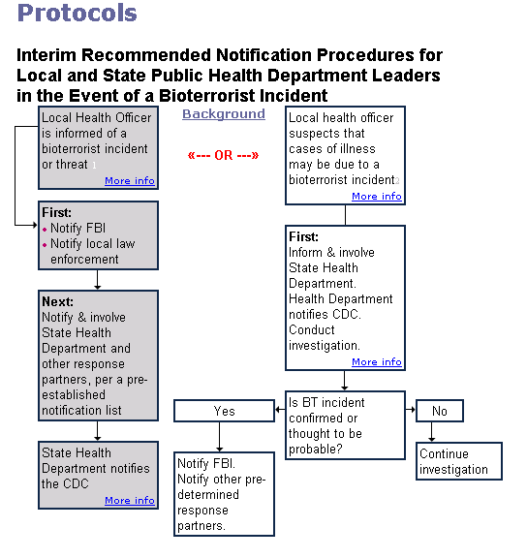

- Once the Emergency Management Agency and/or the Health Department is/are notified of a public health emergency, the Emergency Operations staff shall be notified.

- The Local Health Administrator and/or Health Officer of the Wheeling – Ohio County Health Department shall determine the level of response required of the health department staff.

- All members of the Wheeling – Ohio County Health Department are equipped with text-messaging capable cellular telephones.

- Once the level of response is determined, the Local Health Administrator shall send text messages utilizing the E-team software messaging function and/or the West Virginia PHAlert System to alert the staff.

- Security shall be provided for the Health Department and the Emergency Operations Center.

- All Health Department staff members are equipped with photo identification badges and jump kits for activation of public health emergencies.

D. SUPPORT FUNCTIONS

- Legal Issues
    - The Wheeling – Ohio County Health Department is HIPAA compliant.
    - All Health Department staff members have signed confidentiality statements.
    - Quarantine authority is granted under WV Code, Chapter 16-3-2.

- Human Resources
    - The Health Department staff is supplemented by The Northern Panhandle Medical Reserve Corps.

- Fiscal Resources
    - Mutual Aid agreements have been established to provide and/or receive assistance from other local health departments in the region with no reimbursement penalty.

- Workplace Safety
    - The Health Department follows DOP-15, Workplace Security policy.
    - Personal Protective Equipment is available to all staff members. All staff has been trained in the use of PPE.
    - All Health Department members have been given or offered Hepatitis A and Hepatitis B immunization.

- Logistics
    - A Strategic National Stockpile plan is attached as an annex to this plan. Ohio County also participates as a member of the Northern Panhandle regional team.
    - Memorandums of Understanding (MOUs) are in place to provide adequate equipment and supplies for a response to a public health emergency.

- Communications
    - The EOC has communications with all other counties in the Northern Panhandle and the state EOC.
    - The Health Department has portable radios that are part of the WV SIRN System.
    - The Ohio County EMA’s Radio Amateur Communications Emergency System (RACES) respond to emergencies.
    - Health Department staff members are assigned cellular telephones 24 hours a day/7 days a week.
    - The West Virginia PHAlert System is available for notification of staff members.

- Management of Volunteers
    - A Medical Reserve Corps is organized that will support the Health Department during public health emergencies and during the deployment of the Strategic National Stockpile.
    - The Northern Panhandle Medical Reserve Corps serves the counties of Hancock, Brooke, Ohio, Marshall, Wetzel, and Tyler.

VII. CONTINUITY OF GOVERNMENT

A. LINES OF SUCCESSION

- Wheeling - Ohio County Health Department Health Officer.
- Wheeling - Ohio County Health Department Administrator.
- Wheeling – Ohio County Health Department Threat Preparedness Director.

B. INDISPENSABLE OPERATING RECORDS

- The division chief will be responsible for determining the records essential for post-impact assignment.

2. The division chief will select individuals to fulfill assignments within the division since the chief is familiar with qualified personnel and the objectives of this program.

VIII. ADMINISTRATION AND LOGISTICS

A. HEALTH STATISTICS

1. Vital statistics: The Health Department will continue to collect vital statistics as under normal operating procedures.

- Disease statistics: Data related to disease outbreaks will be collected and forwarded to appropriate state and federal officials.

B. TESTING & INSPECTIONS

All testing of materials will be accomplished using customary procedures by the Health Department. Inspections will be conducted in a normal fashion but with increased frequency.

C. EXPENDITURES

Records will be kept of all expenditures incurred for future reference and reimbursement.

D. PERSONNEL

Administrative and clerical personnel will be made available from the local and county governments as necessary.

E. LOGISTICS

The EOC staff will be responsible for overseeing and coordinating logistics. Maps of the local area will be provided, as needed.

IX. PLAN DEVELOPMENT AND MAINTENANCE

The Wheeling - Ohio County Health Department Administrator will work with the Emergency Management Director, other medical personnel, and the agencies specified in this annex in its development and maintenance. The plan must be reviewed, tested and updated annually.

X. AUTHORITIES AND REFERENCES

- Federal Civil Defense Act of 1950, Pub. L.81-920, as amended.

- The Disaster Relief Act of 1974, Pub. L.93-288, as amended.

- Emergency Management and Assistance, 44 U.S. Code 2.1 (October 1, 1980).

  - WV Emergency Services Act, Chapter 15, Article 5.

  - WV Code Chapter 16

6. Federal Emergency Management Agency. Disaster Operations. CPG 1-6. Washington: FEMA, 1981.

7. Guide for Development of State and Local Emergency Operations Plans. CPG 1-8. Washington: FEMA, 1985.

8. Guide for the Review of State and Local Emergency
Operations Plans. CPG 1-8A/September, 1988.

XI. LIST OF APPENDICES
Appendix 1 – Ohio County MCI Plan
Appendix 2 – Ohio County Mass Fatality Plan
Appendix 3 – Ohio County Threat Preparedness Plan
Appendix 4 – Region 10-11 Hospital Response Plan

