WHEELING-OHIO COUNTY EMERGENCY MANAGEMENT AGENCY
EMERGENCY OPERATIONS PLAN

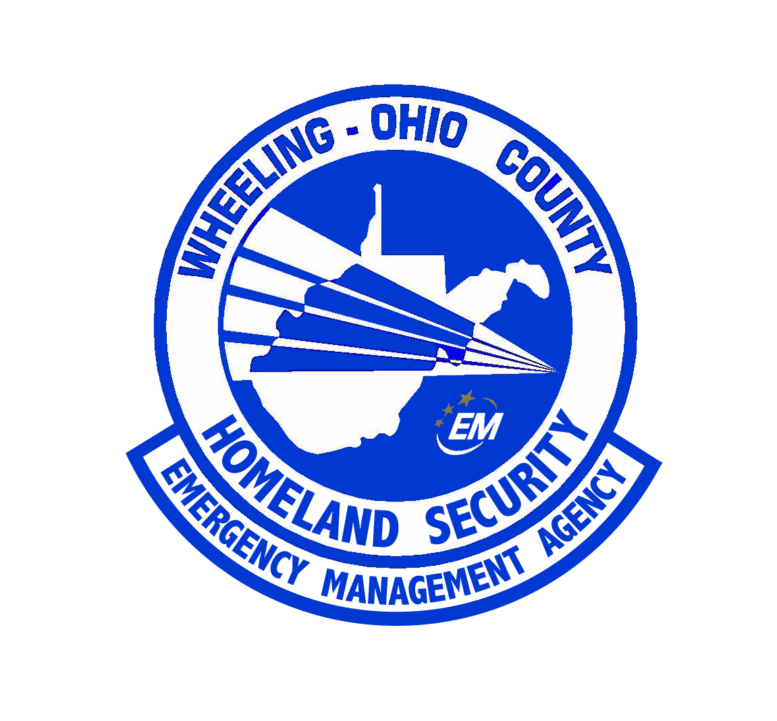

ANNEX SUMMARY INFORMATION PAGE

ANNEX DESIGNATION: | SEARCH AND RESCUE
RELATED FEDERAL ESF: | 9
PURPOSE OF ANNEX: | Search and rescue (SAR) is the employment of resources (private, local, State, and Federal) by governmental agencies to locate and bring to safety persons lost, stranded, or trapped. This annex describes the SAR system and assigns responsibilities in SAR operations. It deals with three types of search/rescue categories: (1) locating lost persons or civilian aircraft, where this is the sole purpose of the operation; (2) industrial explosions or transportation accidents involving SAR; and (3) natural disasters, where search and rescue is an integral part of the overall disaster operations.
WEST VIRGINIA STATUTORY AUTHORITY: | §15-5 & §15-5-9
PRIMARY AGENCY: | Wheeling - Ohio County Emergency Management Agency
SUPPORT AGENCIES: | Ohio County Central Communications, Wheeling – Ohio County Airport, Ohio County Civil Air Patrol, WV National Guard
REFERENCES: | “Guide for All Hazards Emergency Operations Planning”, SLG 101, FEMA, 1996  “Ohio County Emergency Operations Plan”, 2003, amended 2006  “West Virginia Emergency Operations Plan”, Office of Emergency Services, 2002

ANNEX K
SEARCH AND RESCUE

I. PURPOSE

Search and rescue (SAR) is the employment of resources (private, local, State, and Federal) by governmental agencies to locate and bring to safety persons lost, stranded, or trapped. This annex describes the SAR system and assigns responsibilities in SAR operations. It deals with three types of search/rescue categories: (1) locating lost persons or civilian aircraft, where this is the sole purpose of the operation; (2) industrial explosions or transportation accidents involving SAR; and (3) natural disasters, where search and rescue is an integral part of the overall disaster operations.

II. SITUATION AND ASSUMPTIONS

A. Situation

Lost persons/aircraft will take a coordinated effort on the part of several organizations to provide a favorable outcome to the situation.

Resources are available in Ohio County to handle isolated incidents. Major incidents will require state and Federal response.

B. Assumptions

Ohio County authorities will be notified immediately of such incidents.

Ohio County response agencies will establish on-scene command.

A Mobile Emergency Operations Center will be dispatched on all search and rescue missions.

The Wheeling - Ohio County Emergency Management Agency shall be the lead command agency for search and rescue missions. All requests for state and/or Federal assistance will be requested through the W.O.C.E.M.A.

III. CONCEPT OF OPERATIONS

Category 1 - SAR Operations:

a. This type of situation may involve any number of searchers over a large area, but the important distinction is that the lost/missing person(s) or aircraft are the sole reason for the emergency. This SAR operation is, in and of the emergency rather than a function in a more widespread emergency situation.

Operations involving lost aircraft are accomplished in accordance with the West Virginia Civil Air Patrol's SAR plans and the National Search and Rescue Plan. The Wheeling - Ohio County Emergency Management Agency shall be the lead agency in all search procedures. Coordination with the C.A.P. plan and the S.A.R. Plan shall be done by the E.M.A. Director until the situation exceeds that of the local government’s capability and the incident is turned over to the Federal Government (USAF or USCG).

b. Operations involving lost persons will be under the direction of the Wheeling-Ohio County Emergency Management Agency and in coordination with the Ohio County Sheriff, and they will employ local resources, except for such operations of State property, i.e., parks, forests, and non-navigable water ways, will be under the direction of the Department of Environmental Protection.

c. Requests for state assistance may be requested through the Wheeling – Ohio County Emergency Management Director.

Category 2 - SAR Operations:

a. Industrial explosions/transportation accidents. This type of situation will involve a large number of searchers, but the important distinction is that the SAR operation is a function of the emergency rather than the emergency itself. It is important to note that the search is usually restricted to a limited area.

Operations are directed and accomplished by the Wheeling - Ohio County Emergency Management Agency utilizing local resources supplemented by support from the local industrial or transportation company concerned. State assistance may be provided upon request by the Wheeling - Ohio County Emergency Management Director.

Category 3 - SAR Operations:

a. Widespread disaster (major flood, tornadoes). This type of situation utilizes a large number of searchers and its important distinction is that the SAR operation is a function of the emergency wherein a large number of people are being searched for over a large area.

b. Ohio County and local governments must utilize all resources before requesting assistance from the State.
c. Local resources remain under local control in state assisted missions.

d. Overall coordination of SAR operations within Ohio County is performed by the government, except when:

1. The W.O.C.E.M.A. requests the state to perform the coordination function.

2. The Governor directs state coordination of SAR operations in a multi-county area due to the magnitude and severity of the situation.

IV. ORGANIZATION

1. It is the responsibility of the Wheeling - Ohio County Emergency Management Agency in coordination with the local emergency agencies to establish the necessary plans and procedures and conduct all categories of SAR operations within their respective jurisdictions as required.

2. The Wheeling-Ohio County Emergency Management Director shall designate the Northern Panhandle Search and Rescue (NOVASAR) group to direct SAR operations within the jurisdiction. This direction shall be in cooperation with the Wheeling - Ohio County Emergency Management Agency and the Ohio County Sheriff’s Department.

- The Wheeling-Ohio County Emergency Management Agency Director has developed mutual aid agreements with other local jurisdictions.

4. The Wheeling - Ohio County Emergency Management Agency has developed an agreement with NOVASAR for assistance on SAR operations.

5. Requests for State or Federal Assistance for SAR's will be made by the Wheeling - Ohio Emergency Management Director through the West Virginia of Office of Emergency Services.

6. The Department of Public Safety will direct and control ground search and rescue operations for the State.

7. The Department of Natural Resources will conduct SAR operations in State parks, forests and non-navigable waterways.

8. The Wheeling-Ohio County Emergency Management Agency will provide coordination of all county agencies' SAR activities, receive local requests for State and Federal SAR assistance, and request SAR assistance as required from the West Virginia Office of Emergency Services.

9. Whole Community Approach - During disasters involving the entire county, limitations in response may be encountered. Utilizing the National Incident Management System, the EMA Director or his designee shall integrate services and resources from the community. These services and resources are not limited to personnel from Faith Based and Volunteer organizations, community partners from industry, and resources available from industry.

V. DIRECTION AND CONTROL

A. The Wheeling - Ohio County E.M.A. Director, or his designated representative is responsible for conducting search and rescue functions.

B. The Ohio County Sheriff or his designee shall provide on scene coordination of all law enforcement concerns.

- The Mobile Emergency Operations Center shall be placed in service at the scene of all search and rescue operations.

VI. CONTINUITY OF GOVERNMENT

Lines of succession are in accordance with the Basic Plan. The EOC is directly responsible for proper coordination of search and rescue. Provisions for an alternate or backup operation are established.

VII. ADMINISTRATION AND LOGISTICS

The Wheeling-Ohio County Emergency Management Agency shall provide on-scene command of the search in accordance to the Incident Command System and the Integrated Emergency Management System.

VIII. PLAN DEVELOPMENT AND MAINTENANCE

The Director of the Wheeling - Ohio County Emergency Management Agency has the responsibility to periodically review, update, exercise, modify, and approve the Search and Rescue Annex.

IX. AUTHORITIES AND REFERENCES

Sections 305 and 306, PL 93-288, Disaster Relief Act of 1974
National Search and Rescue Plan
West Virginia Code, Chapter 15, Article 5, Section 11

X. LIST OF APPENDICES

Appendix 1 - Joint Statement of WV CAP and WV Office of Emergency Services
Appendix 2 - Search and Rescue Agreement and Procedures
Appendix 3 - Agreement between West Virginia and the Aerospace and Recovery Service
Appendix 4 - Search and Rescue Response Agency Plan
Appendix 5 – Wheeling – Ohio County Airport Emergency Plan

