WHEELING-OHIO COUNTY
EMERGENCY MANAGEMENT AGENCY
EMERGENCY OPERATIONS PLAN

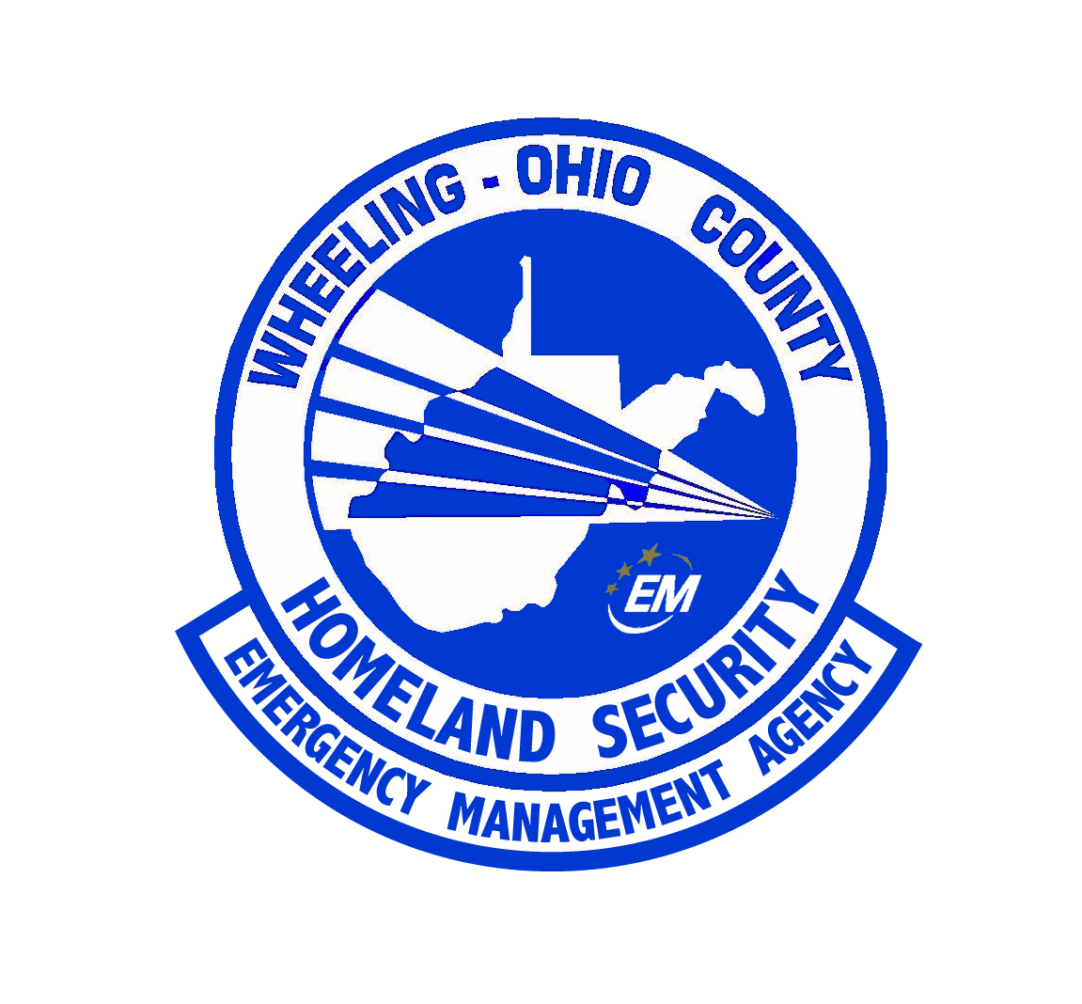

ANNEX SUMMARY INFORMATION PAGE

ANNEX DESIGNATION: | Natural Disasters
RELATED FEDERAL ESF: | IS V
PURPOSE OF ANNEX: | The mission of this annex is to take actions required during natural disasters to save lives, minimize damage, restore and maintain damaged facilities essential to the health, safety and welfare of the Ohio County population.
WEST VIRGINIA STATUTORY AUTHORITY: | §15-5
PRIMARY AGENCY: | Wheeling - Ohio County Homeland Security and Emergency Management Agency
SUPPORT AGENCIES: | Ohio County Central Communications, Ohio County Commission, City of Wheeling, Town of Triadelphia, Village of Bethlehem, Village of Clearview, Village of Valley Grove, Village of West Liberty, All first response agencies
REFERENCES: | “Guide for All Hazards Emergency Operations Planning”, SLG 101, FEMA, 1996  “Ohio County Emergency Operations Plan”, 2003, amended 2006  “West Virginia Emergency Operations Plan”, Office of Emergency Services, 2002

ANNEX IS V
NATURAL DISASTER

I. PURPOSE

The mission of this annex is to take actions required during natural disasters to save lives, minimize damage, restore and maintain damaged facilities essential to the health, safety and welfare of the Ohio County population.

II. SITUATION AND ASSUMPTION

A. SITUATION
The terrain of Ohio County is both urban and rural and is vulnerable to the danger of winter storms, floods, tornadoes, fires, and major forms of disaster. With this situation, a "natural disaster" could strike Ohio County that would endanger the lives and property of the people.

B. ASSUMPTION
Ohio County will suffer some property damage from floods periodically. The danger of a peacetime radiological incident will continue to be a possibility, and it is further assumed that a natural disaster can occur that would affect the people of Ohio County that will require Emergency Management defensive actions.

III. CONCEPT OF OPERATION

In the event of a natural or man-made disaster, Wheeling - Ohio County Homeland Security and Emergency Management Agency authorities will take action to minimize the loss of life and property by using that part of the organization necessary to effectively relieve the situation and recover from disaster damage. Further, emergency situations declared as such by the President of the Ohio County Commission shall constitute a situation requiring Emergency Management response.

IV. ORGANIZATION

A. The Wheeling - Ohio County Homeland Security and Emergency Management Agency

Will establish and provide the following:

1. Warning of any impending danger when known and giving public information.

2. Help as set forth in the various annexes to the Basic Plan as needed.

3. Coordination of activities to restore and maintain vital facilities essential to the health and welfare of the county.

4. Damage assessment.

5. Primary Communications: Public Safety Department frequencies.
Support Communications: State Police, Department of Highways; Citizens Band and RACES radio nets.

6. Maintain contact with the West Virginia Division of Homeland Security and Emergency Management rendering reports on damage and channeling requests for assistance.

7. Point of contact for insurance adjusters and for application of grants-in-aid for the recovery of business and government.

8. The Wheeling - Ohio County Emergency Management Director will if necessary, activate the Emergency Operations Center (EOC) and notify all concerned of his action.

9. Department heads and private agency heads will maintain contact with the Emergency Operations Center (EOC).

10. In the event that a nuclear incident should occur, immediate activation of emergency measures will be taken according to the West Virginia Civil Defense "Peacetime Radiological Incident control Plan." Coordination with the Beaver Valley Nuclear Power Station and Hancock County EMA will take place.

11. This plan is effective for full execution upon a declaration of an Emergency Advisory by the President of the Ohio County Board of Commissioners, acting in consonance with the President of the United States and the Governor of the State of West Virginia.

B. STATE DEPARTMENTS AND AGENCIES

Providing services on the county level will establish and provide:

1. The West Virginia Division of Homeland Security and Emergency Management will provide coordination of police, limited access to damage or accident area, and prevent looting and control traffic.

2. The State Department of Highways will provide assistance in damage assessment; make repairs to highways and bridges and clear debris when necessary for the protection of public health and property.

3. The Department of Human Services will provide welfare services, establish service center for counseling as to available technical assistance programs, and assist in coordinating welfare groups to avoid duplication of services.

4. The Department of Employment Security will provide coordination of all requests for manpower.

5. Military support: For military support in natural disasters, coordination will occur with the West Virginia State EOC.

C. CITY/COUNTY DEPARTMENTS & AGENCIES

Providing Services will establish and provide the following:

1. The Wheeling Police Department (within the city limits) or the Sheriff's Department will provide the coordination of law enforcement.

- The County Fire Departments will provide fire and rescue services to all citizens affected by the natural disaster. The fire departments will fall under the Command and Control of the EOC Fire Sector when a county wide disaster is declared and the EOC is activated. The fire departments will utilize the National Incident Management System to manage all incidents and responses.

- The Wheeling - Ohio County Health Department will provide the coordination of emergency health and medical operations, inoculations and sanitation procedures, including such things as food, water, etc.

4. All City -County Departments and Agencies not listed above will render assistance as directed in the Wheeling - Ohio County Emergency Operations Plan.

D. Whole Community Approach - During disasters involving the entire county, limitations in response may be encountered. Utilizing the National Incident Management System, the EMA Director or his designee shall integrate services and resources from the community. These services and resources are not limited to personnel from NGOs, Faith Based, and Volunteer organizations, community partners from industry, and resources available from industry.

E. FEDERAL GOVERNMENT
- If the Natural Disaster receives a Presidential Declaration, the Wheeling – Ohio County Homeland Security and Emergency Management Agency shall coordinate the recovery efforts of the County.
- The Federal Emergency Management Agency will provide assistance in assisting the City and County with Public Assistance and citizens with Individual assistance depending on the declaration.
- The FEMA Public Assistance Program and Policy Guide is included as an appendix to this annex.
- The Small Business Administration shall assist business owners if applicable to the declaration.

V. DIRECTION AND CONTROL

The Ohio County Administrator and the City of Wheeling’s City Manager will be responsible for procurement of supplies and equipment for the several operating departments following the initial lifesaving activities.

VI. CONTINUITY OF GOVERNMENT

Lines of succession are in accordance with the Basic Plan. The EOC is directly responsible for proper coordination of response to Natural Disasters.

VII. ADMINISTRATION AND LOGISTICS

A. Accurate records must be maintained of services and resources rendered and obtained during emergencies.

B. Detailed documentation of any assistance given to or received from mutual aid jurisdictions must be maintained. These documents should then be delivered to the proper authorities for disposition of future claims.

C. Problems encountered during the disaster as well as their solutions should be noted for discussion in the After-Action Report.

D. An emergency response critique session will be held after the disaster to review each agency's response to determine, if possible, whether the response could be altered in the future to better meet the needs of the population.

VIII. PLAN DEVELOPMENT AND MAINTENANCE

The Wheeling Ohio County Emergency Management Director is responsible for the periodic review, update, exercise, revision, acceptance and approval of the Natural Disaster annex.

IX. AUTHORITIES AND REFERENCES

West Virginia Emergency/Disaster Plan

X. REFERENCES

Federal Civil Defense Guide (FCDG)
West Virginia Emergency Operations Plan
State of West Virginia, Paper of Understanding
Operations Plan 1 (Military Support of Civil Defense, West Virginia Area Command, First United States Army)
West Virginia Civil Defense "Peacetime Radiological Incidents Control Plan"
Ohio County Emergency Operations Plan (Basic Plan)
Order of Board of Commissioners and Ordinance of Wheeling City Council.

X. LIST OF APPENDICES

- Damage Assessment
- FEMA Public Assistance Program and Policy Guide.

