WHEELING-OHIO COUNTY EMERGENCY MANAGEMENT AGENCY
EMERGENCY OPERATIONS PLAN

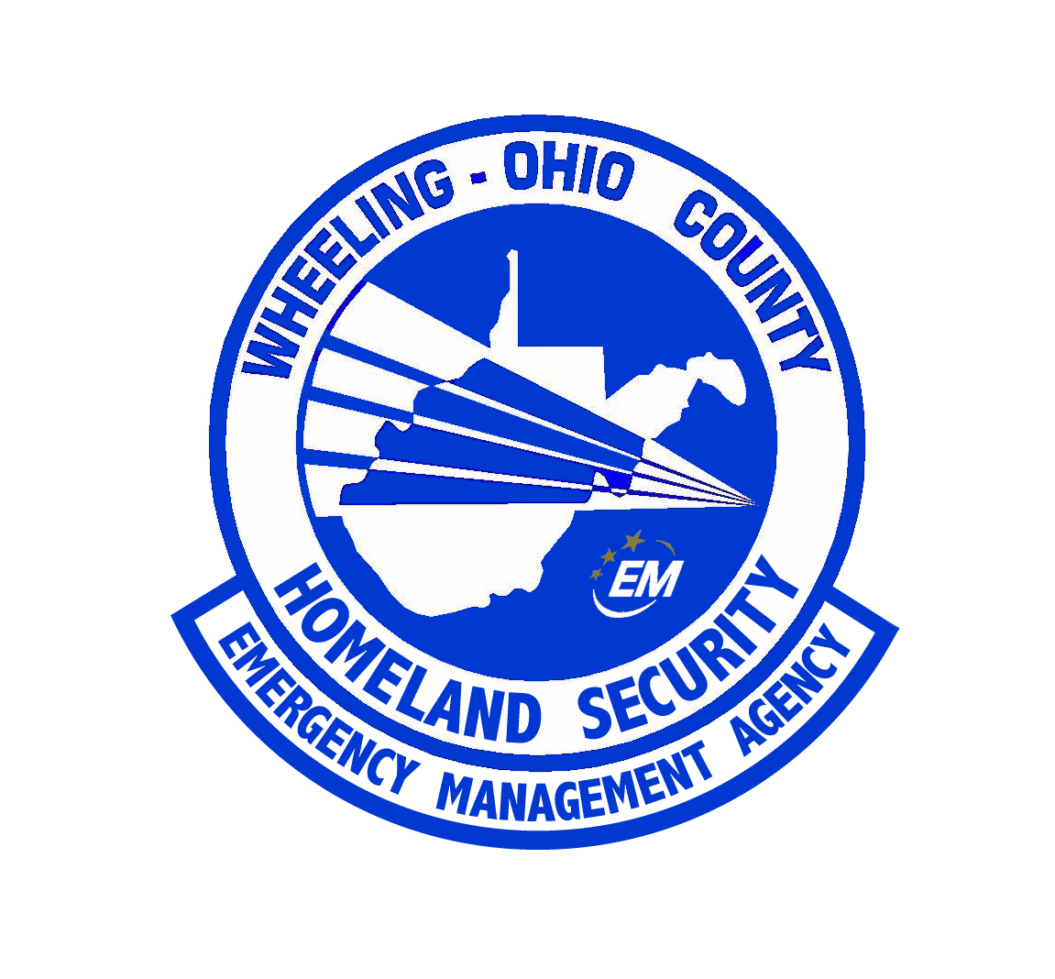

ANNEX SUMMARY INFORMATION PAGE

ANNEX DESIGNATION: | Fire Service
RELATED FEDERAL ESF: | 4
PURPOSE OF ANNEX: | The purpose of this annex is to provide the county with a firefighting capability able to meet the demands of a disaster situation. In addition to firefighting, responsibilities in rescue, warning, hazardous materials, and radiological preparedness operations are addressed.
WEST VIRGINIA STATUTORY AUTHORITY: | WV §29 – 3A – 1(1)
PRIMARY AGENCY: | Wheeling – Ohio County Homeland Security and Emergency Management Agency
SUPPORT AGENCIES: | Ohio County 911 Communications, City of Wheeling Fire Department, Bethlehem VFD, Clearview VFD, Mozart VFD, Stone Church VFD, Triadelphia VFD, Valley Grove VFD, and the West Liberty VFD.
REFERENCES: | “Guide for All Hazards Emergency Operations Planning”, SLG 101, FEMA, 1996  “Wheeling – Ohio County Emergency Operations Plan”, 2004  “West Virginia Emergency Operations Plan”, Office of Emergency Services, 2002

ANNEX ESF 4
FIRE SERVICE

I. PURPOSE

The purpose of this annex is to provide the county with a firefighting capability able to meet the demands of a disaster situation. In addition to firefighting, responsibilities in rescue, warning, hazardous materials, and radiological preparedness operations are addressed.

II. SITUATION AND ASSUMPTIONS

A. Situation.

Fire prevention and control are daily problems faced by fire service personnel. These problems become more significant during emergency situations. Several hazards present difficulties with regard to fire protection, including conflagrations, forest fires, nuclear attack, and hazardous-materials incidents.

Operational Districts are established by the Ohio County Commission and there are mutual aid agreements between volunteer fire departments within the county. Operational districts in the city of Wheeling are defined by the Chief of the department. Mutual aid agreements exist between the city and the county fire departments.

B. Assumptions.

Existing fire personnel and equipment will be able to handle most emergency situations through the use of existing mutual aid agreements. When additional support is required, assistance can be obtained from neighboring counties, state and federal agencies.

III. CONCEPT OF OPERATIONS

A. General.

The responsibilities of fire service personnel in disaster situations are basically the same as in daily operations. Their primary responsibility is life safety and fire control. They are also involved on a regular basis with EMS, vehicle extrication and operational level Hazardous Materials Response. The Wheeling Fire Department as part of the West Virginia Regional Response Team is tasked with specialized rescue that is but not limited to: underwater (SCUBA), swift water, ice, Urban Search and Rescue, Hazardous Material Technician Level Response, and Specialized Technical Rescue (high angle, confined space, and trench). As part of the West Virginia Regional Response Team, the Wheeling Fire Department may be called upon for mutual aid in other parts of the region and the state.

Each department has the primary responsibility for a specific portion of the county. These fire districts are shown on a map located in the E.O.C. and in each department’s headquarters. Their supplemental Emergency Management Agency duties include operation of the public warning system, support for radiological preparedness activities, evacuation assistance, alerting and advising other agencies and the E.O.C. staff on the dangers involved with technological and fires during emergency operations.

B. Phases of Management.

1. Mitigation.

a. Report code violations to the State Fire Marshall for enforcement. (By the authority having jurisdiction)

b. Public safety information programs.

2. Preparedness.

a. Prepare plans, maps, S.O.P.'s, and internal notification/recall lists.

b. Maintenance of equipment, including radiological defense and hazardous materials detection devices.

c. Training of personnel.

d. Development of communications procedures.

e. Pre-planning of hazards.

f. Mock-disaster training.

g. Develop S.O.P.'s that address how the agency will accomplish its assigned tasks and will deal with the hazards the jurisdiction faces.

h. Develop mutual aid agreements.

I. Obtain equipment to perform specialized tasks, i.e., radiological, hazardous materials, etc.

3. Response.

a. Fire control,

b. Search and rescue operations on land and in the water.

c. Hazardous-materials control.

d. Evacuation assistance.

e. Assist handicapped and elderly in evacuation.

f. Traffic control (as needed).

g. Reporting appropriate disaster information to the E.O.C.

4. Recovery.

a. Fire inspection.

b. Decontamination.

c. Cordon off unsafe areas.

d. Prevent further hazards.
e. Assist with recovery efforts and clean up.

IV. ORGANIZATION AND ASSIGNMENT OF RESPONSIBILITIES

A. Fire Sector Leader (FSL)

1. The FSL is responsible for the direction and control of the fire department's operations from the E.O.C. during an emergency. This sector will maintain coordination with all fire departments on manpower, fire fighting and rescue vehicles in the county. The Chief of the City of Wheeling Fire Department is appointed as the County Fire Service Leader in the County Emergency Operations Center. The Ohio County Fire Chief Association’s President may be assigned to the EOC to assist the Fire Sector Leader in coordination of all fire service response during EOC activation during County wide events. Each Fire Chief shall be responsible for the coordination of all fire service related duties within their jurisdictions.

2. The FSLs should keep the EOC Duty Officer informed on the status of major operational activity.

3. The Chief Executives should be briefed periodically on the status of emergency operations and problems confronting the Fire Services Coordinators.

4. The EMA Director and the Chief Executives should be advised by the FSL as to any hazardous materials/radiological situations.

5. Requests for out of the county assistance should be directed to the Duty Officer.
a. If the request is for a mutual aid request for a specific incident and is of short duration, a MOU is not needed,
b. If the request is not under a normal response plan and is for an operational period, a MOU is not needed.
c. If the request is asked for under a City and County State of Emergency, a MOU should be made.
d. If the request is under a State of Emergency proclaimed by the Governor, the request shall follow EMAC requirements.

6. NOTE: The senior jurisdictional Fire Officer responding to a hazardous materials incident will serve as the incident commander (in accordance with the West Virginia Code, Chapter 29, Article 3A, Section 1).

B. County Fire Departments

The Ohio County Fire Departments provide fire fighting service throughout the county. The Ohio County Chief's Association promotes cooperation and mutual aid between fire departments and provides training and educational opportunities to the fire departments. Primary responsibility for the control of fires rests with the fire department for each jurisdiction. When two or more fire departments are involved in any fire fighting operation, the senior officer of the department in whose jurisdiction the fire is located is in charge of coordinating the operation. The Ohio County fire departments are also required to do the following:

1. Coordinate all fire services activities within the county.

2. Control and prevention of fire.

3. Control Hazardous Materials.

4. Support radiological and other public safety operations.

5. Conduct rescue operations.

6. Report fire code violations to the State Fire Marshall for enforcement.

7. Provide fire protection to all facilities used as shelters.

C. Whole Community Approach - During disasters involving the entire county, limitations in response may be encountered. Utilizing the National Incident Management System, the EMA Director or his designee shall integrate services and resources from the community. These services and resources are not limited to personnel from Faith Based and Volunteer organizations, community partners from industry, and resources available from industry.

V. DIRECTION AND CONTROL

A. Wheeling - Ohio County Emergency Management Agency Director

The Wheeling - Ohio County Homeland Security and Emergency Management Agency works closely with the county fire departments to coordinate the best interaction between fire agencies and other Emergency Management Agencies (police, ambulance, rescue, etc.) during a disaster.

B. The EOC Fire Sector Leader (FSL)
The Fire Sector Leader is responsible for coordinating all emergency fire services operations. Each agency will be responsible for operations within its respective jurisdiction. All emergency operations will be handled by standard operating procedures. State and Federal support will be called upon as needed.

C. Miscellaneous

1. The rescue squad(s) participating in these operations will receive mission assignments from the fire department official in overall charge at the primary command post.

2. The release of information concerning the detailed local fire control operations at the site(s) will be the responsibility of the department official in charge at the primary command post.

Public information releases on the overall fire control operations will be issued by the Public Information Officer.

3. The fire service radio systems are operable in the E.O.C. communications center during response operations. A universal language, including terms of the Incident Command System, using NO codes shall be used by all agencies.

4. Within the limits of its capabilities, each department will, under the direction and control of the Wheeling - Ohio County Emergency Management Director or his/her designee, perform radiological monitoring of the environment, and report the results of this effort back to the E.O.C..

VI. CONTINUITY OF GOVERNMENT

Line of succession to each department head are according to the standard operating procedures (S.O.P.'s) established by each department.

Essential records will be kept as safe as possible from fire, water, and other destructive forces.
VII. ADMINISTRATION AND LOGISTICS

A. Administration

Administration of the fire department's affairs will continue under pre-disaster guidelines until determined otherwise by the County Fire Coordinator in conjunction with the E.O.C. executive and operations groups.

B. Logistics

The pre-disaster logistical channels will be utilized until a decision implementing emergency procedures is approved by the County Fire Coordinators in conjunction with the E.O.C. executive and operating group.

VIII. PLAN DEVELOPMENT AND MAINTENANCE

It is the responsibility of each fire department to ensure its own operational capabilities. The Wheeling - Ohio County E.M.A. Director will coordinate the planning of all fire services related to emergency management operations.

IX. AUTHORITIES AND REFERENCES

West Virginia State Code WV §29 – 3A – 1(1)

NFPA 1600, Standards of Disaster/Management amd Business Continuity Program, 2014

X. LIST OF APPENDICES

Appendix #1 - NFPA 1600
Appendix #2 - Activation of the West Virginia Regional Response Team

