WHEELING-OHIO COUNTY
EMERGENCY MANAGEMENT AGENCY
EMERGENCY OPERATIONS PLAN

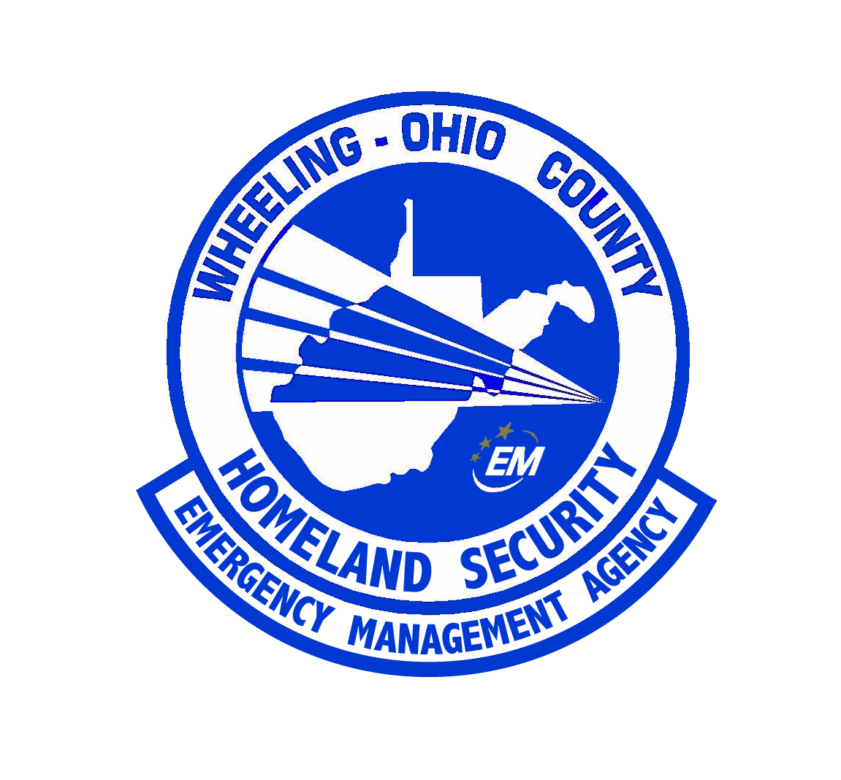

ANNEX SUMMARY INFORMATION PAGE

ANNEX DESIGNATION: | Mine Disasters
RELATED FEDERAL ESF: | IS Mine
PURPOSE OF ANNEX: | The mission of this annex is to take actions required during mine disasters to save lives, minimize damage, restore and maintain damaged facilities essential to the health, safety and welfare of the coal miners of Ohio County. The annex outlines the local, county, and state response to the Federal Response of the Mine Safety and Health Administration’s Mine Rescue program.
WEST VIRGINIA STATUTORY AUTHORITY: | §15-5B-5
PRIMARY AGENCY: | Wheeling - Ohio County Emergency Management Agency
SUPPORT AGENCIES: | Ohio County Central Communications, Ohio County Commission, All first response agencies,  Ohio County Sheriff’s Department
REFERENCES: | “Guide for All Hazards Emergency Operations Planning”, SLG 101, FEMA, 1996  “Ohio County Emergency Operations Plan”, 2003, amended 2006  “West Virginia Emergency Operations Plan”, Office of Emergency Services, 2002  Federal Mine Safety and health Act of 1977  West Virginia Mine Safety Laws and Regulations Section 22A of the West Virginia Stat Code  West Virginia Mine Emergency Rules

ANNEX BB
MINE DISASTERS

I. PURPOSE

The mission of this annex is to take actions required during mine disasters to save lives, minimize damage, restore and maintain damaged facilities essential to the health, safety and welfare of the coal miners of Ohio County. The annex outlines the local, county, and state response to the Federal Response of the Mine Safety and Health Administration’s Mine Rescue program.

II. SITUATION AND ASSUMPTION

A. SITUATION
1. Coal mining is one of the leading industries in West Virginia.
2. Coal mining occurs in Ohio County and neighboring counties of West Virginia.

B. ASSUMPTION
1. Major coal mining disasters have occurred in West Virginia and despite improved safety regulations, future disasters may occur.
2. A coordinated response on the local, county, state, and Federal level is necessary to affect a successful rescue.

III. CONCEPT OF OPERATION

In the event of a mine disaster, Wheeling - Ohio County Emergency Management Agency authorities will take action to minimize the loss of life and property by using that part of the organization necessary to effectively relieve the situation and recover from the mine disaster.

IV. ORGANIZATION

A. The Wheeling - Ohio County Emergency Management Agency

Will establish and provide the following:

1. Activation of the County EOC to coordinate all county response.
2. Activate the following EOC positions:
a. Emergency Management - Ohio County Emergency Planner
b. County Executive
c. Resource Management Sector Commander
d. Volunteer Sector Commander
e. Planning and Intelligence Branch Leader – Ohio County Development Authority Director to establish GIS capability for incident support.

3. Establish a Mobile Emergency Operations Center at the scene.

4. Activate the following National Incident Management System positions:
a. Integrated Incident Command – EOC Director
b. Liaison Commander – EOC Deputy Director shall coordinate activities with the mine officials and Mine Rescue Command.
c. Fire/EMS Sector Commander – Fire Chief in the mine’s jurisdiction.
d. Law Enforcement Commander - Ohio County Sheriff
e. Public Information Officer – Coordinates logistics for the Governor’s Office.
f. Family Services Sector Leader -
g. Resource Management Leader who will coordinate with the EOC Resource Management Sector Commander.
h. Logistics Officers shall coordinate the needs of the Family Services Sector and the Media Sector. In collaboration with the Resource Management Sector Leader shall provide for:
1) Food, portable toilets, electrical supply for the media area.
2) Food and sheltering for the Mine officials and the mine rescue teams.

5. Maintain contact and coordination with the West Virginia Division of Homeland Security and Emergency Management.

6. All reports shall be reported using the E-team system.

7. The Integrated Incident Commander shall establish the following:
a. Incident Command Sector which shall position the Ohio County Mobile EOC and the WVDHSEM Mobile Command Post.
b. Coordination with the Mine Rescue Command Post.
c. Public Information Area.
d. Family Services Area.

B. OHIO COUNTY DEPARTMENTS
1. Upon notification, the Wheeling – Ohio County 911 Communications Center shall dispatch:
a. Fire Response.
b. The Ohio County Sheriff’s Department
c. The Wheeling – Ohio County Emergency management Agency personnel.
d. The Valley Grove VFD with Command #1.

2. The Sheriff's Department will provide the coordination of law enforcement and security at the site.

3. The Ohio County Volunteer Department having jurisdiction at the mine site will provide:
a. Incident command for county public safety response.
b. Develop a Mass Casualty Sector at the scene dependent upon the number of trapped miners. The Sector commander shall assign: a triage officer, a transport officer, staging officer, and mass casualty sector officers for the various injury classifications.
c. The Mass Casualty Sector Commander shall coordinate activity with the West Virginia Regional response Team.
d. The Staging Officer shall establish a Staging Area in the area of the mine. All staged fire and EMS apparatus shall be assigned to the area.

4. The County Medical Examiner shall:
a. Establish a temporary morgue at the site.
b. Coordinate activities with the state Medical Examiner.

5. The Ohio County Health Department in collaboration with the Region X-XI EMS Agency shall:
a. Establish a Counseling Sector.
b. Coordinate with the Family Services Sector.
c. Provide Critical Incident Stress Debriefing teams for first responders.
d. Assist with the collaboration of all clergy at the Family Services Center.

6. All County Departments and Agencies not listed above will render assistance as directed in the Wheeling - Ohio County Emergency Operations Plan.
C. STATE DEPARTMENTS AND AGENCIES

1. The Governor’s Office shall:
a. Coordinate Federal and State response.
b. Act as a liaison between the family members and all response agencies.
c. Coordinate all Public Information Statements.

2. The Department of Military Affairs and Public Safety will provide coordination of police, limited access to damage or accident area, and prevent looting and control traffic.

3. The Division of Homeland Security and Emergency management shall:
a. Establish an onsite State Command Post next to the Ohio County Mobile EOC.
b. Coordinate State and County response.

4. The Department of Health and Human Resources shall provide critical incident stress debriefing and counseling services to rescuers and family. They will coordinate with the Family Counseling Sector Officer.

5. The West Virginia Office of Mine Health and Safety Training.
The West Virginia Office of Miners' Health Safety & Training is responsible for the supervision of the execution and enforcement of the provisions of the state's mining laws and rules. Prime consideration is given to the protection of the safety and health of persons employed within or at the mines of the state. In addition, the agency protects and preserves mining property and property used in connection with mining activities.
The agency pursues this mandate by impartially executing and enforcing the state's mining laws and administrative rules in a co-operative spirit through a comprehensive approach that includes not only inspection, enforcement, and investigative activities, but also and perhaps more importantly, by aggressively conducting timely and functional training activities focused on all segments of the mining industry.
The West Virginia Office of Mine Health and Safety Training shall be the lead state agency in the actual mine rescue effort.
Contact information for the local office is: Fairmont Regional Office: 205 Marion Square. Fairmont, WV 26554-2800 (304) 367-2706 fax: (304) 367-2707 Hours: 9:00 to 5:00 Monday through Friday.

D. FEDERAL AGENCIES
1. Mine Safety and Health Association
The U.S. Labor Department's Mine Safety and Health Administration (MSHA) help to reduce deaths, injuries, and illnesses in the nation's mines with a variety of activities and programs. The agency develops and enforces safety and health rules applying to all U.S. mines, helps mine operators who have special compliance problems, and makes available technical, educational and other types of assistance. MSHA works cooperatively with industry, labor, and other Federal and state agencies toward improving safety and health conditions for all miners. MSHA's responsibilities are spelled out in the Federal Mine Safety and Health Act of 1977.

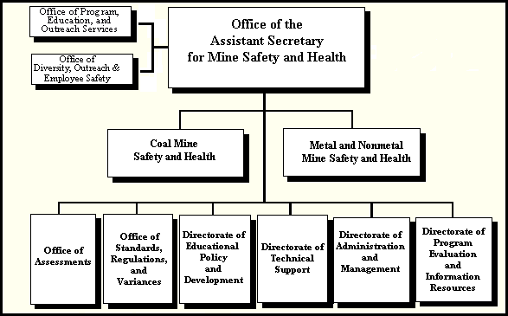

E. MINING COMPANY
1. Shall report the incident to the WV DHSEM Mine and Industrial Accident Rapid Response System (MIARRS) at 1-866-WVSAFETY (1-866-987-2338) within 15 minutes.

2. Shall report the incident to the Ohio County 911 Center within 15 minutes.

3. Conduct all rescue and response operations with in the guidelines of Federal and state laws.

F. VOLUNTEER AGENCIES
1. American Red Cross shall provide food and sheltering for the family members. The ARC shall coordinate all activities with the Ohio County Family Services Sector Commander.
2. Salvation Army shall also assist with providing food for family members, rescuers, and media officials.

G. Whole Community Approach - During disasters involving the entire county, limitations in response may be encountered. Utilizing the National Incident Management System, the EMA Director or his designee shall integrate services and resources from the community. These services and resources are not limited to personnel from Faith Based and Volunteer organizations, community partners from industry, and resources available from industry.

V. DIRECTION AND CONTROL

The Ohio County Administrator will be responsible for procurement of supplies and equipment for the several operating departments following the initial lifesaving activities.

VI. CONTINUITY OF GOVERNMENT

Lines of succession are in accordance with the Basic Plan. The EOC is directly responsible for proper coordination of response to mine disasters.

VII. ADMINISTRATION AND LOGISTICS

A. Accurate records must be maintained of services and resources rendered and obtained during emergencies.

B. Detailed documentation of any assistance given to or received from mutual aid jurisdictions must be maintained. These documents should then be delivered to the proper authorities for disposition of future claims.

C. Problems encountered during the disaster as well as their solutions should be noted for discussion in the After-Action Report.

D. An emergency response critique session will be held after the disaster to review each agency's response. To determine, if possible, whether the response could be altered in the future to better meet the needs of the population.

VIII. PLAN DEVELOPMENT AND MAINTENANCE

The Wheeling Ohio County Emergency Management Director is responsible for the periodic review, update, exercise, revision, acceptance, and approval of the Mine Disaster annex.

IX. AUTHORITIES AND REFERENCES

West Virginia Emergency/Disaster Plan

X. REFERENCES

Federal Civil Defense Guide (FCDG)
West Virginia Emergency Operations Plan
Ohio County Emergency Operations Plan (Basic Plan)

X. LIST OF APPENDICES
Appendix #1 –Mine Rescue Teams

